Math: This month we will be starting
Unit 3. The lessons consist of learning
about measurement, time, and graphs.
These concepts may be a little difficult.
Therefore, we will be spending more
time on certain lessons.

Reading Workshop: This month we will continue our study of non-fiction text, using previewing, predicting, and many other strategies. These will allow us to learn and expand our schema of the world around us.

Writing Workshop: This month in writing workshop we will be learning various skills to help us research a topic and create a non-fiction piece of our own. Students will be choosing an animal of their choice to research and complete another writing assignment.

Social Studies: As we finish up our Economy of Michigan unit, we will transition to studying the Early History of Michigan including the people and the events that occurred to create our great state.

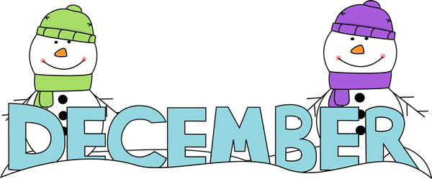
NEWSLETTER

Art: Displayed in the hallway are some of the projects we completed throughout November. These projects connect to the different subjects we are learning in class including Social Studies and Handwriting. This month we will continue using different mediums to display our artistic accomplishments.

Word Study/Words Their Way: We will continue to switch between Word Study words and our Wordly Wise book throughout the month. The Word Study Words will be in the student’s binders to practice during the week along with their Spelling Contracts.

Science: Students have been working on learning about the resources of Earth. Some areas they have focused on include weather, minerals and different types of rocks.

REMINDERS
*December 3
Multiplication Quiz
*December 4
New Spelling Words and Contract
*December 10
Spelling Test & Contract Due
*December 18
New Spelling Words and
Contract
*December 22
Winter Party – 10:30a.m. -12:00 p.m.
*December 23 - January 4:
No School – Winter Break
*January 5:
School Resumes
*January 8:
Spelling Test & Contract Due

